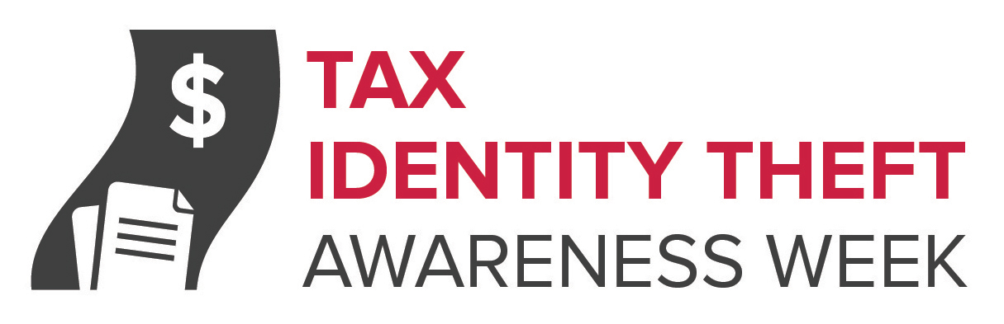
Did You Know It’s Tax Identity Theft Awareness Week?

Ready for tax season? If you haven’t heard about tax identity theft, you may not be.

This week is Tax Identity Theft Awareness Week. Tax identity theft happens when someone files a phony tax return using your personal information — like your Social Security number — to get a tax refund from the IRS. It also can happen when someone uses your Social Security number to get a job or claims your child as a dependent on a tax return. Tax identity theft is the most common form of identity theft reported to the Federal Trade Commission. The IRS says tax identity theft is a top priority and says it has hired new staff, explored new technologies, and adopted new procedures to fight it.

“Tax identity theft is a significant and growing issue,” said Jessica Rich, Director of the FTC’s Bureau of Consumer Protection. “It’s critical that we make sure consumers are aware of how they can prevent it, and if they are victimized, what steps they can take to recover as quickly as possible.”

Tax identity thieves get your personal information in a number of ways. For example:

- someone goes through your trash or steals mail from your home or car

- imposters send phony emails that look like they’re from the IRS and ask for personal information

- employees at hospitals, nursing homes, banks, and other businesses steal your information

- phony or dishonest tax preparers misuse their clients’ information or pass it along to identity thieves

So what can you do about it? To lessen the chance you’ll be a victim:

- file your tax return early in the tax season, if you can, before identity thieves do.

- use a secure internet connection if you file electronically, or mail your tax return directly from the post office. Don’t use unsecure, publicly available Wi-Fi hotspots at places like coffee shops or a hotel lobby.

- shred copies of your tax return, drafts, or calculation sheets you no longer need.

- respond to all mail from the IRS as soon as possible.

- know the IRS won’t contact you by email, text, or social media. If the IRS needs information, it will contact you by mail.

- don’t give out your Social Security number (SSN) or Medicare number unless necessary. Ask why it’s needed, how it’s going to be used, and how it will be stored.

- get recommendations and research a tax preparer thoroughly before you hand over personal information.

- if your SSN has been compromised, contact the IRS ID Theft Protection Specialized Unit at 1-800-908-4490.

- check your credit report at least once a year for free at annualcreditreport.com to make sure no other accounts have been opened in your name.

What if you are a victim? Tax identity theft victims typically find out about the crime when they get a letter from the IRS saying that more than one tax return was filed in the their name, or IRS records show they received wages from an employer they don’t know. If you get a letter like this, don’t panic. Contact the IRS Identity Protection Specialized Unit at 1-800-908-4490.

More information about tax identity theft is available from the FTC at ftc.gov/idtheft and the IRS at irs.gov/identitytheft.

